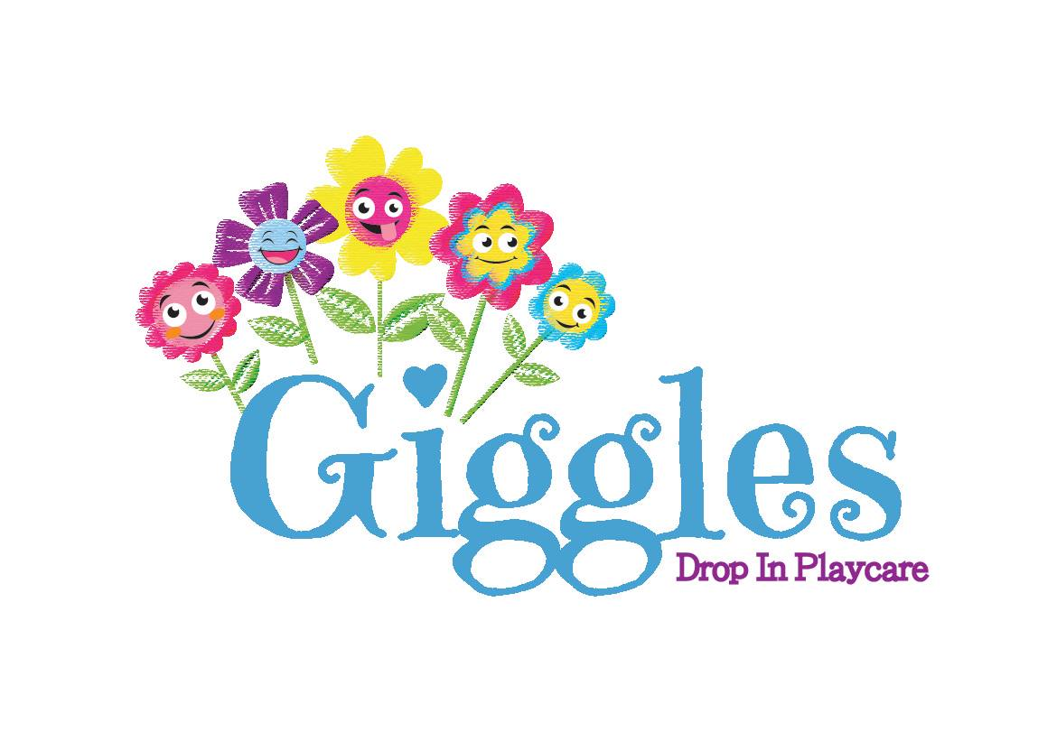 **Infant Information Form**

This form must be completed in its entirety and turned in

before or at the time of an infant’s first drop-off at Giggles.

**Please, write clearly and legibly.**

Child’s Name: ________________________________

Will your infant be using a bottle during their time at Giggles? Yes / No

If “Yes”, please, give us the relevant details of the type of milk they use, how much they usually drink at each bottle, when they get a bottle (i.e. anytime they want one, at certain times, just at nap, etc.), the temperature they prefer (hot, warm, room temperature, cold), and any other information about bottle feeding for your child.

________________________________________________________________________________________________________________________________________________________________________________________________________________________________________

Does your child drink water yet? Yes / No

From bottle or sippy cup? ____________________________________________

Does your baby eat anything besides liquids? Yes / No

If “Yes”, please, give us the relevant details about how they eat. Do they eat baby food – by spoon or from a pouch? Do they eat finger foods – puffs and other baby snacks, tiny bites of regular food, mostly independently eats soft food, etc.? Anything that they tend to like or dislike? Other food related information we should be aware of? Etc.

________________________________________________________________________________________________________________________________________________________________________________________________________________________________________

Does your infant have any other needs related to eating or drinking? Yes / No

Any burping tips or techniques that work best for your child? Do they use gas, colic or other such drops? If they are eating food, are there common allergens that they have not been exposed to yet? Is the baby a big eater or more of a snacker? Etc.

________________________________________________________________________________________________________________________________________________________________________________________________________________________________________

How does your child usually sleep?

Please, let us know how your baby is used to sleeping – sleeping position, rocking/swinging or still, swaddled or free moving, with or without pacifier/bottle, music or white-noise, any other specific information and will make napping go smoothly. Does your child have a nap schedule or sleep on an as needed basis? Etc.

________________________________________________________________________________________________________________________________________________________________________________________________________________________________________

Does your infant use a pacifier/binkie/soother Yes / No or have another comfort item? Yes / No

Please, let us know how your baby uses the item - all the time, when upset, at nap, etc. Also, is there a special word that your family calls the item(s)?

________________________________________________________________________________________________________________________________________________________________________________________________________________________________________

Is there any known mobility issues or physical needs that that child has?

Please, let us know if there is anything that we need to watch out for or help the child with during their time at Giggles.

________________________________________________________________________________________________________________________________________________________________________________________________________________________________________

Is there any other information that you would like us to know to help make your baby’s time at Giggles as pleasant as possible?

__________________________________________________________________________________________________________________________________________________________________________________________________________________________________________________________________________________________________

Thank you for your time!