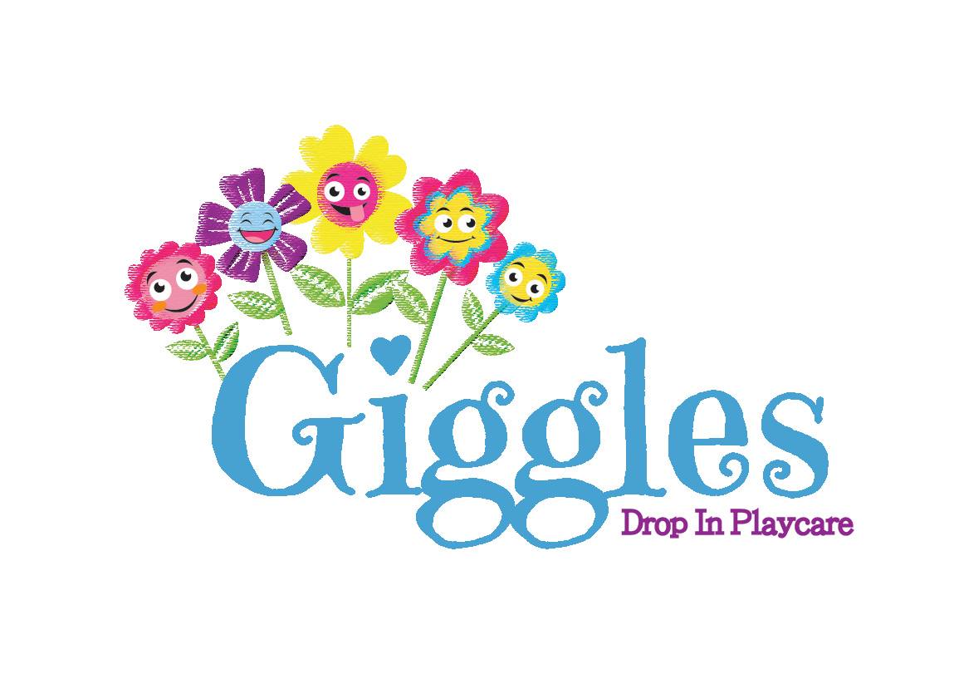
Admission Form

This form must be completed in its entirety and turned in
at least a day prior to a child’s first drop-off at Giggles.
Please, write clearly and legibly

Guardian Name: _________________________________ Relationship to Child(ren): ___________________
Cell Phone #: ________________________ Home/Other (Please specify) Phone #: __________________________

Workplace: ___________________________________________ Work Phone #: _______________________
Name Location
Mailing Address:____________________________________________________________________________
Street Address City State/Zip
Email Address(es): ___________________________________ _____________________________________
Primary (Required) Other (optional)

Guardian Name: _________________________________ Relationship to Child(ren): ___________________
Cell Phone #: ________________________ Home/Other (Please specify) Phone #: __________________________

Workplace: ___________________________________________ Work Phone #: _______________________
Name Location
Mailing Address:____________________________________________________________________________
Street Address City State/Zip
Email Address(es): ___________________________________ _____________________________________
Primary (optional) Other (optional)

Please provide the following information about your child(ren)

Legal Name: ______________________________ Legal Name: ______________________________
Name Called: _____________________________ Name Called: _____________________________
Birthdate: _______________ Gender: _________ Birthdate: _______________ Gender: _________
Address: _________________________________ Address: _________________________________

Legal Name: ______________________________ Legal Name: ______________________________
Name Called: _____________________________ Name Called: _____________________________
Birthdate: _______________ Gender: _________ Birthdate: _______________ Gender: _________
Address: _________________________________ Address: _________________________________

Legal Name: ______________________________ Legal Name: ______________________________
Name Called: _____________________________ Name Called: _____________________________
Birthdate: _______________ Gender: _________ Birthdate: _______________ Gender: _________
Address: _________________________________ Address: _________________________________
OTHER AUTHORIZED PICK-UP ADULTS and EMERGENCY CONTACTS
Please provide at least one Emergency Contact
Authorized Pick-up: any person allowed to drop-off & pick-up children, besides parents/guardians.
Emergency Contact: a person whom we can contact in case of an emergency if parents/guardians cannot be reached.
Check if the person listed is an Authorized Pick-up, Emergency Contact, or both.
Children WILL NOT be released to anyone not on the authorized pick-up list.

Emergency ⬜ Authorized ⬜ Emergency ⬜ Authorized ⬜
Name: ____________________________________ Name: _______________________________
Relationship: _______________________________ Relationship: __________________________
Address: __________________________________ Address: ______________________________
City, State, Zip Code: ________________________ City, State, Zip Code: ____________________
Cell/Home Phone #: _________________________ Cell/Home Phone #: _____________________
Work Phone #: _____________________________ Work Phone #: _________________________

Emergency ⬜ Authorized ⬜ Emergency ⬜ Authorized ⬜
Name: ___________________________________ Name: ________________________________
Relationship: ______________________________ Relationship:___________________________
Address: _________________________________ Address: ______________________________
City, State, Zip Code: _______________________ City, State, Zip Code: ____________________
Cell/Home Phone #: ________________________ Cell/Home Phone #: _____________________
Work Phone #: ____________________________ Work Phone #: _________________________

Emergency ⬜ Authorized ⬜ Emergency ⬜ Authorized ⬜
Name: ___________________________________ Name: ________________________________
Relationship: ______________________________ Relationship:___________________________
Address: _________________________________ Address: ______________________________
City, State, Zip Code: _______________________ City, State, Zip Code: ____________________
Cell/Home Phone #: ________________________ Cell/Home Phone #: _____________________
Work Phone #: ____________________________ Work Phone #: _________________________
__________________________________________________________________________________
AUTHORIZATION FOR EMERGENCY MEDICAL ATTENTION
In the event I cannot be reached to make arrangements for emergency medical care, I give consent for the facility to secure any and all necessary emergency medical care for my child(ren). I authorize the person in charge to take my child(ren) to the following medical center(s):

⬜ North Valley Hospital ⬜ Kalispell Regional Medical Center
1600 Hospital Way Whitefish MT 59937 310 Sunnyview Lane Kalispell MT 59901
(406) 863-3500 (406) 752-5111

⬜ Name of Other Emergency Medical Care Facility: ________________________________________
Address: ____________________________________ Phone Number: _________________________
__________________________________________________________________________________

HOW DID YOU HEAR ABOUT US?

_____________________________________________________________________________
MEDICAL/DOCTOR INFORMATION

Child’s Name: _______________________ Child’s Name: ___________________
Doctor’s Name: _________________________ Doctor’s Name: _______________________
Phone Number: _________________________ Phone Number: _______________________
⬜ Up-to-date Immunization Records ⬜ Exemption Form ⬜ Up-to-date Immunization Records ⬜ Exemption Form
⬜ Doctor Check* ⬜ Doctor Check*

Child’s Name: _______________________ Child’s Name: ___________________
Doctor’s Name: _________________________ Doctor’s Name: _______________________
Phone Number: _________________________ Phone Number: _______________________
⬜ Up-to-date Immunization Records ⬜ Exemption Form ⬜ Up-to-date Immunization Records ⬜ Exemption Form
⬜ Doctor Check* ⬜ Doctor Check*

Child’s Name: _______________________ Child’s Name: ___________________
Doctor’s Name: _________________________ Doctor’s Name: _______________________
Phone Number: _________________________ Phone Number: _______________________
⬜ Up-to-date Immunization Records ⬜ Exemption Form ⬜ Up-to-date Immunization Records ⬜ Exemption Form
⬜ Doctor Check* ⬜ Doctor Check*

*Doctor Check The above doctor has examined this child within the past year and the child is medically able to safely be in care at Giggles Drop-In Playcare.

SPECIAL CARE INFORMATION

Please, list any serious allergies, medical conditions, medications, dietary requirements, physical care needs, behavioral proclivities, or any other information that Giggles staff should be aware of to properly care for each child. If a child is on any prescriptions, you will need to fill out a Medication Form only if we will be administering said medication while the child is in care. Giggles Playcare cannot be held liable for any issues that may arise if we are not given pertinent information on the child.

Child’s Name: _______________________ Child’s Name: ____________________________
Pertinent Info: _________________________ Pertinent Info: _____________________________
_____________________________________ _________________________________________
_____________________________________ _________________________________________
_____________________________________ _________________________________________
SPECIAL CARE INFORMATION (continued)
Child’s Name: _______________________ Child’s Name: ___________________________
Pertinent Info: _________________________ Pertinent Info: ____________________________
_____________________________________ ________________________________________
_____________________________________ ________________________________________
_____________________________________ ________________________________________

Child’s Name: _______________________ Child’s Name: ___________________________
Pertinent Info: _________________________ Pertinent Info: ____________________________
_____________________________________ ________________________________________
_____________________________________ ________________________________________
_____________________________________ ________________________________________

MY CHILD ATTENDS ANOTHER DAYCARE OR SCHOOL

Please add your child’s information if applicable. This information is for communicable disease tracing.

Child’s Name: _______________________ Child’s Name: ________________________
Facility Name: _________________________ Facility Name: _________________________
Phone Number: _________________________ Phone Number: ________________________

Child’s Name: _______________________ Child’s Name: ________________________
Facility Name: _________________________ Facility Name: _________________________
Phone Number: _________________________ Phone Number: ________________________

Child’s Name: _______________________ Child’s Name: ________________________
Facility Name: _________________________ Facility Name: _________________________
Phone Number: _________________________ Phone Number: ________________________

GIGGLES DROP-IN PLAYCARE POLICIES AND PROCEDURES

Please check all boxes that apply:

⬜ I acknowledge receipt of the facility’s Parent Handbook, either on the website or in person.

⬜ I have read, understand and agree to the facility’s policies & procedures outlined in the Handbook.

⬜ I have signed & turned in the back page of the Handbook and kept the main document for reference

At Giggles Playcare, photographs are taken by the staff of the children as they go about their daily activities. Staff members will never use these photos for personal reasons or display them outside of work. Giggles sometimes uses these photographs for purposes such as advertising in print and/or electronically, promotional posts on our website and/or social media and displaying the prints in our facility. Names are NEVER used in conjunction with any posted or displayed photographs. We will always honor the wishes of the families regarding the use of photos.

Please check all the boxes that apply:

⬜ YES, I give permission for my child(ren)’s photos to be displayed inside the Giggles facility

⬜ NO, my child(ren’)s photos may not be displayed inside the Giggles facility

⬜ YES, I give permission for my child(ren)’s photos to be used on Giggles’ social media accounts

⬜ NO, my child(ren)’s photos may not be used on Giggles’ social media accounts

⬜ YES, I give Giggles permission for my child(ren)’s photos to be used in advertising campaigns

⬜ NO, my child(ren)’s photos may not be used in Giggles’ advertising campaigns
_________________________________________________________________________________

ADMISSION FORM SIGNATURE

I confirm that all of the information provided in this Admission Form is
complete and accurate to the best of my knowledge.
I agree to update Giggles Drop-In Playcare if any information changes.

_______________________________________ ___________________________
Parent Signature Date

